*functions prioritized by order

|  |  |  |  |
| --- | --- | --- | --- |
| Item Name | Requirements | Difficulties | Functions |
| Race Car | Needs to be controllable.  Drifts around corners.  Drift with key c and turning.  Move in x and y  Making collisions cause damage to car and obstacle it hits  When nitro is used car speed doubles for 5 seconds.  Has a police level | Implementing drifting to be different than just dodging obstacles | start()  moveUp ()  moveDown ()  driftLeft()  driftRight()  collide ()  increaseCollateralDamage()  collectCoin()  increaseNitro()  useNitro()  downHealth()  getPoliceChance() |
| Race Track | First level will just be straight track. Second level turns and some obstacles will be introduced. Third level many obstacles and tons of civilians and traffic.  If it gray part is hit then collateral damage is increased | 300000 pixels | increaseCollateralDamage() |
| Obstacles | Needs to be able to change. Different sizes and shapes changing from different obstacles: mines, crevices, etc. Use random number generator to decide between different sizes and kind like kind 1 vs 2 and size 1 vs 2 vs 3.  Should appear every 2 seconds. Hitting obstacles increase collateral damage. | Using randomizer to make it chose what obstacle.  Making them appear every 2 seconds | chooseKind()  chooseSize ()  placeDown()  downHealth()  increaseCollateralDamage() |
| Bitcoins | Needs to be able to be collected and randomly generated on the track.  They are in groups of 10.  Random number from 0-100 to determine whether it is coin or collectible. If the random number is above 85 then it is a “collectible” item. | How to make hacking work while playing | generate()  getCollected() |
| Hacking Coin | Collectable like nitro and bitcoin but you have to click the hack button within two seconds to hack the player for the bitcoin. The hacking coin appears every 2 minutes. |  | coinSwitch() |
| Nitro | When car hits nitro then car receives nitro which they use with key z or n. |  | addNitro()  place() |
| Civilians | Civilians are like an obstacle but move and if hit then they die and the collateral damage is increased and cars police level goes up. | Moving them and making them small enough to be dodgeable | move()  death()  increaseCollateralDamage() |
| Cars | Cars move opposite and same direction of player. Hitting a car increases collateral damage |  | increaseSpeed()  increaseCollateralDamage() |
| Police/Roadblock | Like an obstacle but only appears when the police level of car increases which is from car hitting obstacles and civilians. If car hits then roadblock then health goes down. | Giving player enough time to see police | place() |

There are no design assumptions besides having to know how to code JS. No need for prewritten code beside maybe the start template that we were given for our first project.

Race Car must have health, collateral damage, coins and nitro.

Obstacle must have size and kind variable.

Car must have speed variable.

I like this a lot.

Police level increases with collateral damage. Every 1 second of collateral damage is 1 collateral damage. If civilian or civilian car is hit then collateral damage is increased by 10 points.

The drift mechanism is hard but definitely feasible.

Drift mechanism, the players must press brake (press c or <) at the start of the curve and release it at the end of the curve. If this break is delayed or prolonged, the car will spin out of control and the game will end. If they do not drift, the game will also end and show an image of the car destroyed at the turn.

You will first need to start the game and allow the car to move side to side and then start moving the track which will make the car look like its moving which is how to start then start implementing curves, drifting, obstacles, police level, and then rest.

Controls:

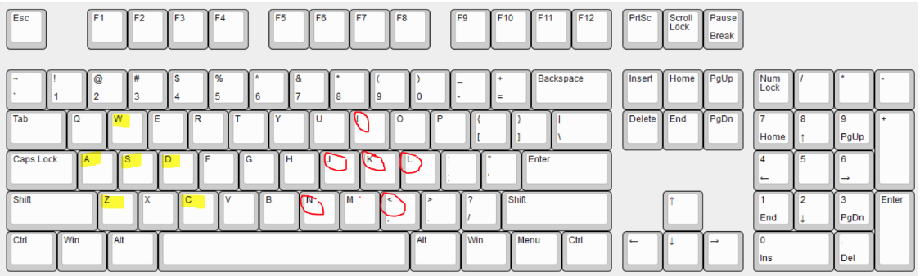

WASD moving player 1

Z nitro activate

C break activate

IJKL moving player 2

N nitro activate

< break activate